**Test Case 3**

When this message “Press ENTER to continue.” appears, means that the program is “paused”.



When paused, input “q”.

Input “y” (continue the program if input “n”)

Input “y” (exit the program if “n”)

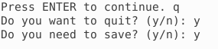

“File saved” shows up and back to home screen.

